AMP Solution Day

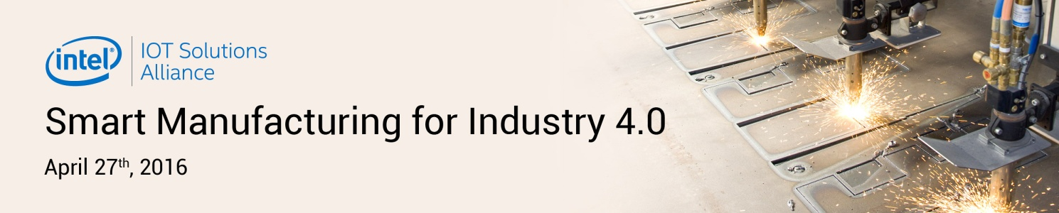
Registration Form

Please kindly fill out and return the completed registration form to Mr. Theerapat Songlerk via email.
Email: theerapat.so@tnmetalworks.com
Tel: +662 115 5000 ext. 388
M: 66 8 5252 9393

I’d like to sign up for 2015 NEXCOM Global Partner Conference!
Company Name:
Country:
First and Last Name :
Title/ Position:
Email:

Special Dietary Needs (Please Mark the Appropriate Box)
- Vegetarian
- Others, please specify:

