Registration Form

Host by: 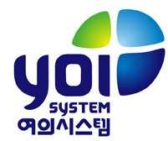

Kindly please email/ fax your completed registration form to:
Contact: Annie Seo
Email: seojk@yoisys.com
Tel: +82-31-737-8885
Registration Deadline: 30th May, 2014

Yes, I would like to join NEXCOM Solution Day
Topic: NISE Automation
Date: June 13th 2014
Time: 09:50-16:30
Venue: EL Tower
Address: (137-889) 213 Gangnam-daero Seocho-gu, Seoul, South Korea

Company Name
Contact
Office Tel
Mobile
Email
Number of attendees

